[ACEEE Letterhead]
Copyright License Agreement

Date: _______May 18, 2012______________
Author name: __________Jorge Ortiz_________________________________ (“Author”)
Employer of Author (if Submission (defined below) is a “work made-for-hire”):
____________________________________________ (“Employer”)
Title of work: Live, Continuous Energy Auditing of Miscellaneous Electrical Loads: Methodology and Results

1. Author hereby grants to the American Council for an Energy-Efficient Economy (“ACEEE”) the nonexclusive, worldwide, perpetual, irrevocable, royalty-free, and sublicensable right and license to reproduce, distribute, perform, display (publicly or otherwise), and prepare compilations or derivative works based upon, all or any portion of any copyrightable works submitted to ACEEE in connection with the ACEEE Summer Study Proceedings, including without limitation, literary works and any separate copyrightable works (e.g., charts and graphs) incorporated therein (“Submissions”). If the Submissions were created in the course of the Author’s employment as a “work made-for-hire,” Employer grants to ACEEE the nonexclusive, worldwide, perpetual, irrevocable, royalty-free, and sublicensable right and license to reproduce, distribute, perform, display (publicly or otherwise), and prepare compilations or derivative works based upon, the Submissions. ACEEE may distribute the Submissions in print, digital, electronic or any other format or medium now known or hereafter discovered.
2. Author and, if the Submissions were created in the course of the Author’s employment as a “work made-for-hire,” Employer (together, the “Contributor”), agree not to reproduce, distribute, perform, display (publicly or otherwise) the Submission or any compilation or derivative work based on the Submission prior to the first day of the ACEEE Summer Study on Energy Efficiency in Buildings (in even years (e.g., 2012, 2014, 2016, etc.)) or ACEEE Summer Study on Energy Efficiency in Industry (in odd years (e.g., 2013, 2015, 2017, etc.)) for which the Submission is made and to which it is submitted.
3. Author represents and warrants that the Submissions are original and authored by Author (and any co-authors), that all co-authors have been disclosed to ACEEE, and that Author has the right and authority to enter into this agreement and to grant the rights granted in this agreement.
4. To the extent that Author has any “moral rights” with respect to the Submissions, including any right of inspection or approval of the uses of any Submissions or any portions thereof, Author agrees to waive and decline to assert such rights, and agrees that ACEEE may reformat and otherwise modify and prepare derivative works of the Submissions, regardless of the medium into which the Submissions may be modified and regardless of the effect of such modifications on the integrity of the Submissions. Author hereby grants to ACEEE and its representatives permission to publicly identify the Author by name as an author and to include biographical information in any materials related to the ACEEE Summer Study Proceedings.
5. Contributor agrees that this Copyright License Agreement contains all the terms of the parties’ agreement and may not be amended, supplemented, or modified except by an instrument in writing executed by ACEEE and Contributor. Contributor understands that this Copyright License Agreement is to be construed in accordance with and governed by the internal laws of California, without giving effect to any choice of law rule. Contributor understands that any legal suit, action or proceeding arising out of or relating to this Copyright License Agreement will be commenced in the federal court in Washington, D.C., or in state court in the District of Columbia, and that ACEEE and Contributor each hereto submit to the exclusive jurisdiction and venue of such court. NEITHER ACEEE, NOR ANY OF ITS DIRECTORS, OFFICERS, EMPLOYEES, CONSULTANTS, AGENTS, LICENSORS OR OTHER REPRESENTATIVES (“ACEEE PARTIES”) WILL BE LIABLE FOR ANY INDIRECT, INCIDENTAL, CONSEQUENTIAL, EXEMPLARY OR PUNITIVE DAMAGES OF ANY KIND IN CONNECTION WITH THE SUBMISSIONS UNDER ANY LEGAL THEORY. THE ACEEE PARTIES’ MAXIMUM LIABILITY FOR ALL DAMAGES, LOSSES AND CAUSES OF ACTION RELATED TO THE SUBMISSIONS SHALL BE ONE HUNDRED DOLLARS ($100).

ACKNOWLEDGED AND AGREED:

Jorge Ortiz
___________________________________________
Author’s Name

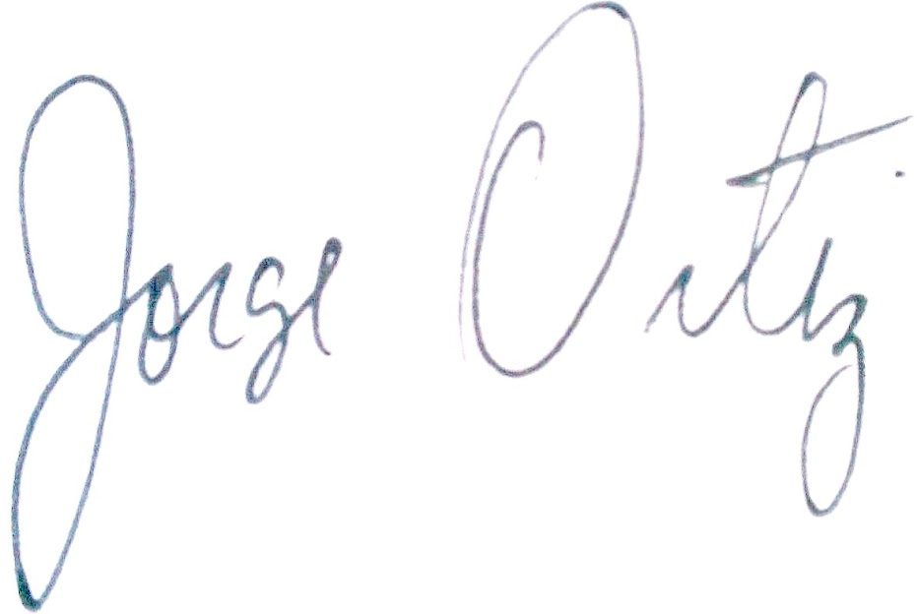
___________________________________________
Author’s Signature

May18,2012_________________________________
Date

___________________________________________
Name of Employer’s Authorized Representative
___________________________________________
Employer’s Name
___________________________________________
Signature of Employer’s Authorized Representative
___________________________________________
Date

___Jason Trager________________________
Co-Author’s Name (if any)
___Gavin Saldanha__________________________
Co-Author’s Name (if any)
David Culler________________________________
Co-Author’s Name (if any)

Paul Wright______________________
Co-Author’s Name (if any)

